**Experiment 31. Design a Automatic Night Lightening system**

**Circuit Diagram:**

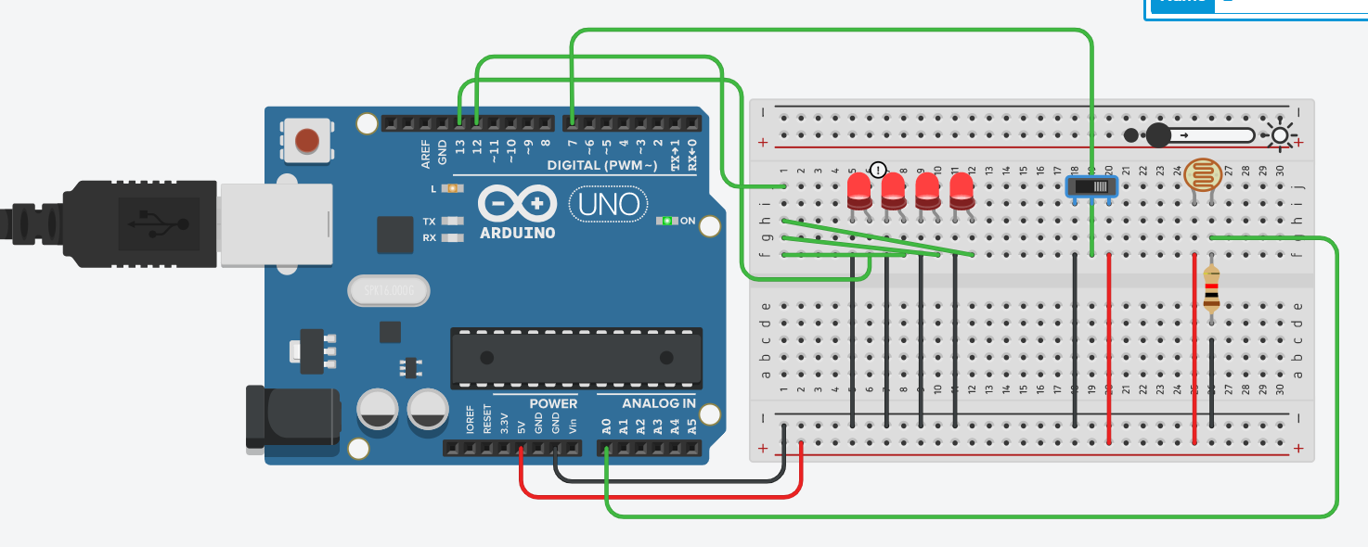

**THEORY**

**Concept Used:** We have used the concept of LDR(Light Dependent Resistor) which is a variable resistor whose resistance depends on the intensity of light around it. We have also used Switch, Arduino Uno R3, and LEDs to create the system.

**Learning & Observations:** We learnt how we can use LDR, Switch, Arduino and LEDs to design a Automatic Night Lightening system.

We observed that when the brightness is over 50% then only one LED is glowing and when brightness is less than 50% all LEDs are constantly ON

**CODE**

void setup()

{

pinMode(13, OUTPUT);

pinMode(12, OUTPUT);

pinMode(7, INPUT);

Serial.begin(9600);

}

void loop()

{

int s=digitalRead(7);

int l=analogRead(A0);

if(s==HIGH)

{

if(l<500)

{

digitalWrite(13, HIGH);

digitalWrite(12, HIGH);

}

if(l>500)

{

digitalWrite(13, HIGH);

digitalWrite(12, LOW);

}

}

if(s==LOW)

{

digitalWrite(13, LOW);

digitalWrite(12, LOW);

}**PROBLEMS & TROUBLESHOOTING**

During the designing of this system we encountered some problem in using LDR which we rectified connecting resistor in the circuit. We also used Switches to change between the different LEDs in the circuit.

**PRECAUTIONS**

Make sure that all the connections are proper and tight. Use Resistance in the connection of LDR. Use switches in the circuit to switch between different LEDs.

**LEARNING OUTCOMES**

We learnt how we can use LDR, Switch, Arduino and LEDs to design an automatic Night lightening system.